ABSTRACT

With the advent of new technology and smartphones. Business models can now be modified to take advantage of all the tools at their disposal to provide value to their customer, maintain loyalty and get a grip on their competitive edge. This document serves to give an overview on how the Toyota Zimbabwe mobile application intends to enhance communication, brand awareness and accessibility of service to customers while on the go. The document outlines a background of Toyota Zimbabwe (Pvt) Ltd, as well as highlighting challenges at hand, and objectives of the project. The application caters for Toyota Parts, Service and New Vehicle sales customers. The objective of the study is to find the best technologies that can support the new app to bring the best value for the customer and profitable business to the company. Feasibility and planning of the project was carried out, covering areas of economical, technical, and operational. Risk and work plan is also given; using financial techniques like cost benefit analysis. Data gathering was done through questionnaires, interviews and observations. The current system was also analysed using dataflow diagrams and activity diagrams. Other ways to develop the application were explored, such as in-house development and outsourcing. Requirements analysis was conducted to assess on the tools to enable the success of the mobile application. The document concludes with interface design, highlighting the dataflow and context diagram of the mobile application to be created, together with entity relationship diagrams. Sample design of the actual application was created, covering aspects such as backup, tests data and security of the system, which is mostly a user’s concern.

DECLARATION

I, Aspha Mahapa, hereby declare that I am the sole author of this project. I authorize Trust Academy and the Midlands State University to lend this project to other institutions or individuals for the purpose of scholarly research.

Signature _________________________________ Date _____________________________

Approval

The project entitled Toyota Zimbabwe Mobile Application meets the regulations governing the award of the degree BMIS Bachelor of Science in Management Information Systems Department of Computer Science and Information Systems in the Faculty of Science and Technology by the Midlands State University in collaboration with Trust Academy. It has been approved for its contribution to intellectual knowledge and literal presentation.
Supervisor____________________________________
Date_________________________________________

ACKNOWLDGEMENTS

Primarily I would like to give a special thank you to the Lord Almighty, who is my enabler and divine inspiration, Praise, Power and Glory be ever unto Him. I would want to give my humble appreciation to Toyota Zimbabwe who enabled me to come up with such an innovative research and all the other information I needed. My gratitude also goes to my partner Lontia Chigaga for the unwavering support throughout this project research. I would also want to extend gratitude to my supervisor, Mr J. Makota, for helping me, providing his insight and guidance. Finally, all thanks go to my parents for all the sacrifices they made with the sole aim of making me successful as far as education is concerned. I greatly appreciate, may the Almighty bless you.

Table of Contents
ABSTRACT i
DECLARATION ii
ACKNOWLDGEMENTS iv
1.2 Organizational Profile 1
1.2.1 Organizational Background 2
1.2.2 Organizational structure 2
1.2.3 Company vision 3
1.3 Problem definition 4
1.5 Objectives 5
1.6 Instruments 5
1.6.3 Data collection methodology 5
1.7 Justification 6
1.8 Conclusion 6
2.1 Introduction 7
2.2 Business Value 7
2.3.1 Technical feasibility 9
2.4.1.3 Hardware 12
2.3.2 Economic Feasibility 12
2.3.3 Operational Feasibility 16
2.3.5 Social Feasibility 17
2.5 Work Plan 17
2.6 Gant Chart 18
2.6 Conclusion 18
3.1 Introduction 19
3.2 Information gathering methodology 19
3.2.1 Interviews 19
3.2.2 Questionnaire 20
3.3 Analysis of the existing system 22
3.4 Process Analysis 23
3.4.1Activity Diagram of current system 23
3.5 Data Analysis 25
3.5.1 Context Diagram of Proposed System 25
3.5.2 Data flow diagram 26
3.6 Weakness 26
3.7 Evaluation of Alternatives 26
3.7.1 Buying software packages 27
3.7.2 Outsourcing 27
3.7.3 In-house development 28
3.7.4 Improvement 29
3.7.5 Recommendations 29
3.8 REQUIREMENTS ANALYSIS 30
3.8.2 Functional requirements 30
3.8.2 Non-functional requirements 30
3.7 Conclusion 31
4.1 Introduction 32
4.2 System design 32
4.2.1 Context Diagram of the Current System 33
4.2.2 Data Flow Diagram of the Proposed System 34
4.3 Architectural design 36
4.3.1 Physical design 37
4.4 User Interface design 37
4.4.1 Main menu design 38
4.4.2 Input design 39
4.4.2 Output design 39
4.5 Process Design 40
4.7 Database Design 41
4.3.2 Database Scripts 42
4.8 Security Design 44
4.9 Backup Design 44
4.10 Test design 45
References 46
Interviews 47

List of Tables
Table 2.1 Other Software Requirements…………………………………………11
Table 2.2 Hardware specifications……………………………………………….12
Table 2.3 Cost Benefit Analysis………………………………………………….14
Table 2.4 Net Profit Table………………………………………………………..15
Table 2.5 Gantt chart……………………………………………………………..17
Table 2.5 .1 Gantt chart for the project schedule…………………………………18

List of Figures

Figure 1.1: Organogram………………………………………………………….3
Fig 3.1 Activity Diagram………………………………………………………...24
Fig 3.2 Context Diagram of the proposed system……………………………….25
Fig 4.1 Context Diagram of the Current System………………………………...34
Fig 4.2 Data Flow Diagram the for the Proposed System……………………….35
Fig. 4.3 Architectural Design …………………………………………………....36
Fig 4.4 Main Menu Design……………………………………………………….38
Fig 4.5 Upload music Page………………………………………………………39
Fig 4.6 Music menu arranged by category……………………………………….39
Fig 4.7 Database design..........................................................................................42
Fig 4.8 Login screen……………………………………………………………...44

CHAPTER 1: INTRODUCTION

1.1 Introduction
This project involves the design of a Mobile Application System that will facilitate the effective communication with customers within and without the organisation. Toyota Zimbabwe is an organization with the customer at heart henceforth a development like this will assist in customer interactions, service bookings, marketing, sales adverts, news and updates on any Toyota activities. Customers will also be able to make transactions through the App whilst they are on the go. Daily tips on vehicle care and special vehicle campaigns will be delivered to the mobile App. In case of emergencies on the road customers can either call for recovery or standby technician at the touch of a dial. The application will be available on Google Play store for free download; this will make it easy for distribution. At the same time in store, clients can request for the installation APK file, which can be received via Bluetooth.
The chapter will highlight the background of the research, problem definition, significance, objectives, and hypothesis together with the justification to system development.

1.2 Organisational Profile

Toyota Zimbabwe (private) Limited is incorporated in Zimbabwe under The Companies Act (Chapter 24:3) of Zimbabwe. The company is engaged in the motor trade, dealing in motor vehicles, spares and services.
The expansive Toyota distributor network is owned by (TTC) Worldwide, the TTAF (Toyota Tsusho Africa) Distributor Management Team (D M T) manages it in Africa. D M T comprises specialists, experienced and skilled team members in different distributor vehicle management. The team regularly visits Distributors to get a thorough understanding of customers’ needs and deliver unique people and business solutions to ensure a value adding service.

Toyota Zimbabwe is owned 100% by Toyota Tsusho Corporation (Japan) so are other distributors in Africa.
Namely:
- Toyota Zambia (Distributor for Zambia)
- Toyota Malawi (Distributor for Malawi)
- Toyota De Angola (Distributor for Angola)
- Toyota East Africa (Distributor for Kenya)

1.2.1 The Toyota Group consists of 13 companies

  - Toyota Motor Corporation
  - Toyota Machine Works, Ltd
  - Toyota Auto Body Co. Ltd
  - Aisin Seiki Corporation
  - Denso Corporation
  - Toyota Loom Works
  - Toyota Tsusho Africa Ltd

  - Toyoda Boshoku Corporation
  - Towa Real Estate Co. Ltd
  - Toyota Central Research & Development Laboratories, Inc.
  - Kanto Auto Works, Ltd
  - Toyota Gosei Co. Ltd

1.2.2 Organizational Background

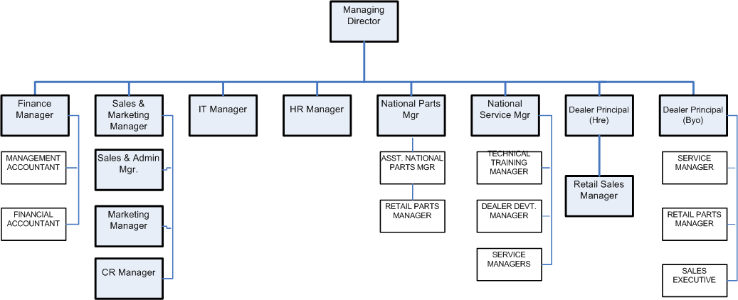

Fig 1.1: Organisational structure for Toyota Zimbabwe.

1.2.3 Value Statement

Toyota Zimbabwe mission statement is shown in the form of a house model, which also captures the value statements. The value statements form the foundation of the house model and these are “Unity in the Toyota family, respect and Integrity”

Unity – built from a shared vision, a cherished hope, an altruistic aim, or a cause for the common good. It is our unity that gives us sustenance, strength, and courage to make the impossible possible. Combining with determination and commitment, unity makes the biggest task seem easy for us.
Respect – we aim to feel or show honor, consideration or esteem for each other. We also show respect in how we relate to each other and it is not about what we do, but who we are.
Integrity - we will build trust and confidence in all our business relationships through honesty, commitment and the courage to do what is right. We work with our customers and prospects openly, honestly and sincerely. When we say we will do something, we will do it; when we say we cannot or we will not do something, then we will not do it. It is how we act when no one is looking.

1.2.4 Mission Statement
The Toyota Zimbabwe mission statement is captured in the format of a “house model”. The House Model is a business and cultural change model that depicts the organization as a HOUSE, where each part that constitutes the building plays an important factor in its resilience to achieve the aim. The house model covers both the mission and value statements.

Below is a pictorial view of the Toyota Zimbabwe House model.
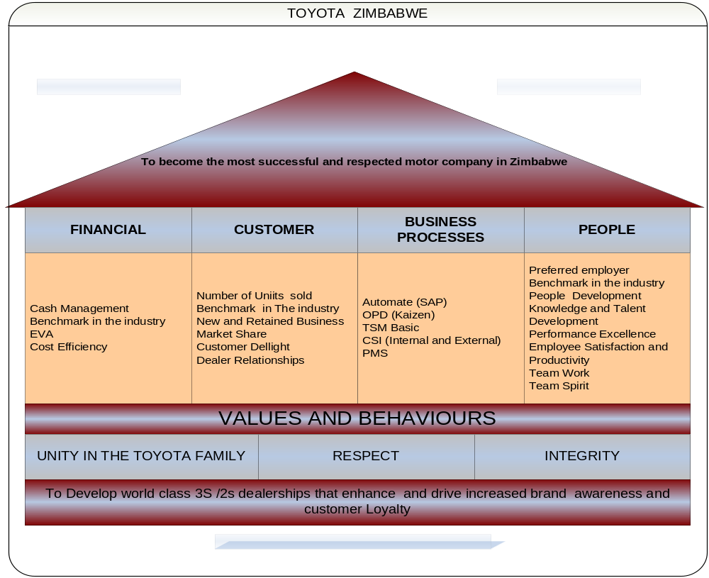

Fig 1.2 : House Model Mission Statement for Toyota Zimbabwe.

1.2.5 Core Business
The company is engaged in the motor trade, dealing in motor vehicles, spares and services. In simpler terms, we could identify Toyota Zimbabwe as an automotive company. The company has 3 branches; one in Harare CBD -for vehicle and parts sales and service (3s Dealership). The Msasa branch has vehicle service, repairs and parts sales. This is the same case with branch in Bulawayo.

1.3 Problem definition

The company is currently using a manual system thus telephones to get bookings or communicate with customers. This traditional system has been in use since the inception of the company. However, the inefficiencies in this system is that the process might face some delays because of congestion of the telephone lines. Capturing of information might also be a hustle, as there can be many errors when trying to take down information over the phone.
1.4 Project Aim
The major aim of the research is to develop a mobile application for Motor industry which enables easy business process between clients and dealers without any inconvenience of communication and geographical barriers or other unnecessary costs.

1.5 Objectives
The objectives of the study it to design a mobile application that:
1) Allows a customer to book their vehicle in for service.
2) Notify customers of any campaigns or events as and when they occur.
3) Enables a customer with more than one vehicle to maintain their fleet on their mobile phone.
4) Enable customer to interact with Sales, Parts, service and Cr departments whilst on the go.
5) Enable customers to browse the Vehicle showroom and browse the mobile website on their phones

1.6 Instruments
- JAVA - It is an object oriented programming language that will be used for the Android Mobile Application.
- C++ -Also to develop Android Security Modules and storing API (Application Programmable Interface ) KEYS
- PHP – a web server language that also runs in APACHE server environments .
- MySQL Server – this will work as a database .
- APACHE – Web server – this will be used to host web services.

1.6.1 Data collection methodology
- Interviews
- Questionnaires
- Observation

1.7 Justification

The Mobile Application will complement the currently manual systems in the following ways:

- Creation of a smart working environment with less paper work.
- Reduce congestion of calls for enquiries or complaints.
- Efficiency in booking for service and customer updates.
- Reduction in errors that can occur because of using a manual system.
- Customer retention as they will always be up to date with will be happening.
- Customers will be able to maintain there on fleets over the App.
- More ways to advertise via the phone will be availed.
- Customer information will be easy to retrieve and keep by use of a fleet database.
- Convenience to the customer on the go.
- Market expansion as we can reach a wider audience.

1.8 Conclusion

Focus was on highlighting an introduction involving giving a brief outline on the company’s history, identification of the problem and possible solutions to the problems. The methodologies to be used were outlined together with a clear justification to support the proposed idea in problem solving. We then move on to the next chapter were we will look at the visibility and viability of the proposed project to see if it is worth undertaking.
CHAPTER TWO: FEASIBLITY AND PLANNING PHASE

2.1 Introduction
Planning in simple terms is to guide to action (Janet, 2012). This phase of the project looks at practicality of development of the system. Guiding the project to action involves the process of defining orderly arrangement of activities and resources in bid to deliver a required product thus communicating project activities. The activities are communicated through identifying the tasks to be performed, the persons to perform the tasks, times when the tasks are to be carried out and completed that is scheduling of tasks, sequence of execution of tasks and the resources required to accomplish the tasks (ITRM Guideline, 2006). In addition, planning phase spells out the justification of developing the Toyota Zimbabwe Mobile application through examination of the business values realized from developing and implementing the application, as well as the feasibility of developing the application that is the realism of the application.

2.2 Business Value

Toyota Zimbabwe (Pvt) Ltd.’s business is hinged on the customer, the value put in the customer is of very high importance, and whatever the company does it is for the customer’s satisfaction. As Zimbabwe is under an economic shakedown, customer retention has become a core of the company’s business making sure that a customer who has purchased a vehicle is offered service and parts backup for the life of that particular vehicle.
What better way of retaining customers by way of providing on-hand information and digitalizing that loyalty programs Toyota has in place. At the same time, customers will be able to book for service, do a parts enquiry and view the Toyota Vehicle showroom whilst on the go.

The proposed application will prove to be more efficient and reliable to the organization, and if correctly implemented the organization can secure a competitive edge over its competitors’ other vehicle distributors, in handling its customer image. Below are some of the expected benefits:
- The mobile app can greatly contribute to your brand awareness. This can be done in two parts:
Brand -the mobile app is like a blank billboard sign. The app will be stylish, hip, functional and informative. In addition, the app will have features customers will love – as it will be branded and beautifully designed.
Recognition- Toyota is a very popular brand but this app will get more customers involved and the sooner they will be inclined to buy Toyota products and service. In advertising, this is called the “effective frequency”: as a rule of thumb, hearing and/or seeing your brand approximately 20 times is what will get you truly noticed.
- Improve Customer Engagement – Customers will be linked to the company’s Toll free numbers through the app, were they can interact either through instant messaging to customer representatives in the Toyota Call centre wherever they might be. Thus taking care of the customer’s communication and other needs.
- Stand Out From the Competition-These days mobile apps at the small business level are still rare, and this will be a unique offering that will set Toyota ahead of other dealers in the Automotive industry it will be a big leap ahead of all competitors.
- Cultivate Customer Loyalty -Toyota app will aim at keeping the brand’s impact on customers so that they are faithful to the brand. At the same time making a true and sincere connection with your customers, and making them a loyal lover of your product and/or service

2.3 Feasibility Study
According to Thompson (2005) defines feasibility as a process that is used for identifying - problems, opportunities, determining objectives, describing situations, defining successful outcomes and benefits associated with several alternatives for solving a particular problem. The study helps to track unresolved logs and the responsible personnel. Aspects to consider are:
- Technical feasibility
- Economic feasibility
- Operational feasibility
- Social feasibility

2.3.1 Technical feasibility
Technical feasibility determines whether the organization has access to, hardware, software, and does it have management with expertise. It embraces the ability to use up-to-date technology thus new and more computers that are powerful, whether the identified user needs may be satisfied using current software or hardware. The success to this analysis also depends on whether the staff is willing to undergo training hand is not resistant to change. The aspects to be covered in technical feasibility are:
- Technical expertise
- Technical equipment and software

2.3.1.1 Technical Expertise

In this case, the analysis is trying to establish whether the developer involved in the project was fully technically competent to produce the specified product. Considering resources that we have at hand, we can outsource the cloud storage and other complex operations because the focus is on Vehicle sales, parts sales and service. The organization’s responsibility will be administration of the application therefore less technical skill will be wanted.

The success of the development needs at least skills of C and Java and Windows OS. In investigating the technical feasibility of the developing team, we will be answering the following questions that are provided below. It involves answering the questions that may be raised by the technical team developing the system and the answering the questions that may be raised by the technical team operating the system.
The main questions to answer during feasibility study include the following:
•Does the necessary technology exist to develop the suggested solution?
•Does the proposed equipment have the technical capacity to hold the data required to use the new system?
•Does the technical team possess the necessary skill to develop the proposed solution?
•Will the proposed system provide adequate response to inquiries, regardless to the location of the user?
•Can the system be upgraded if developed?
•Are the technical guarantees accurate, reliable and feasible?
Microprocessor technology is widely applicable in home appliance and other industrial appliances making it feasible and applicable. The android technology is common and it being an open source it is not difficult to learn and apply the technology. The equipment to be used is reliable and can be applied to collect and process the data required by the user. Android technology is based on java and it being an open source technology it is not difficult for us to learn and use it to develop the android application and the C++ language is also an open source technology that will develop the security module to protect sensitive information to make it difficult for hackers to access security keys to the back end if the system. The necessary network infrastructure is already available to send and receive the text to and from the user as well as placing calls. The system is technically feasible as the above requirements are attainable in development.
During this phase, we also examined the feasibility of the target market in terms of their capability to operate this technology. Any user who is capable of using a smart phone or any mobile phone can use this technology.

2.3.1.2 Software Requirements
We have the experience and expertise to build and deploy system using these technologies and our portfolio team has been building software system integrating mobile application using these technologies
- Windows 7 onwards
- Android Studio
- Visual Studio Code
- Sublime Text
- Dev C++
- File Zilla

Table 2.1 Other Software Requirements
SOFTWARE | VERSION REQUIRED
JDK(Java Development Kit and JRE) | 8
MinGW64 | 3.4.2.
Work Station Operating System | Windows 8.1
Server Operating System | Windows 2012 Server

2.3.1.3 Hardware
For the best results in building this application, the following are hardware and software components specifications, which are recommended.

Hardware Specifications
Table 2.2 Hardware specifications
ITEM | MINIMUM | RECOMMENDED
Processor | 2.1 GHz | 4.2 GHz
Cache Processor | 512Kb | 2 MB
Memory | 4 GB | 8GB
Hard Drive Disk | 250 GB | 5 TB
Network Card | 10/100 | 10/100
UPS |  | APC Smart ups 1000va

2.3.2 Economic Feasibility
Economic feasibility attempts to institute whether the anticipated project is economically or financially feasible. This is the analysis of the anticipated costs to incur during and after the implementation of the Toyota Zimbabwe Mobile application. Economic feasibility is defined as Cost-Benefit Analysis, which measures the financial impact of the project. With Toyota Zimbabwe Mobile, application shall be both an in-house and an outsourced because eternal skilled personnel especially on cloud storage where Toyota Zimbabwe will buy cloud space from another provider and this would mean risk transfer to them, thus reducing costs of data loss, will monitor its operations.

Cost Benefit Analysis (CBA)
Cost benefit analysis is a recognized analysis designed to evaluate whether the benefits of the project overshadow its costs. Benefits can be either tangible or intangible.
Tangible benefits
Ward and Daniel (2006:21) stipulated that tangible benefits are those that can be measured by an objective, quantitative and often financial measures.
- An improved user-friendly interface therefore little personnel training required.
- Improved user satisfaction, better quality services from the studio thereby increasing organization’s efficiency
- Elimination of unnecessary paperwork
Intangible benefits
They are as follows:
- Global reach of new customers.
- On the go service wherever you are.
- Improved work performance in all business operations since marketing online reduce run around time.
Costs
There are the two types of expected costs that are incurred during and after the implementation of the online system. These are:
Development costs
Development is the costs that incur only once when the application is being developed. For example, they can be estimated from the onset of the project and they should be refined at the end of each phase of the project. These development costs include:
Personnel Costs:
Training
- New computer equipment and software costs
Operational costs
These tend to occur throughout the lifetime of the application. For instance, application maintenance costs. They can be classified as fixed and variable costs. Fixed costs occur at regular intervals but at relatively fixed rates, for example; lease payments, software license payments and payments for support call outs.
Variable Costs-occur in proportion to some usage factor. For instance, supplies such as that of hard disk drives, internet usage costs.
Below shows a detailed description of costs and benefits.
Table 2.3 Cost Benefit Analysis
Year | 2017 | 2018 | 2019
Benefits | US$ | US$ | US$
Estimated services in figures | 1 000 | 1 500 | 3 000
Reduced Paperwork | 100 | 100 | 500
Total Benefits | 1 100 | 1 600 | 3 500
Traveling cost | 500 | 0 | 0
Express mail cost | 300 | 0 | 0
Additional Hardware | 700 | 0 | 0

Table 2.4 Net Profit Table
COSTS AND BENEFITS | 2017  (USD) | 2018  (USD) | 2019  (USD)
Development costs | 25 875
Running costs | 5 380 | 5 380 | 5 380
Total costs | 31 255 | 5 380 | 5 380
Benefits to Organisation
Tangible |  | 47 000 | 4000
Intangible benefits (Estimated Monetary value ) |  | 9 600
Total Benefits |  | 56600
Net Benefits |  |  | 25 345

Net Profit=Total Benefits-Total Costs
= (1 100 + 1 600 + 3 500) – 6 000
=$200
Payback Period:
Wearne (1989:36) described payback as the time taken for the positive cash benefits from a project to equal the cash invested in that project. Payback period is the time taken to break-even or payback the initial investments.
In order to recover $200 which is the initial investment, it will yield Total Amount of Yearh1 which is $1 100+ 9/12($1 600) =$ 1 200.This would take 1 Year and 9 Months

Return on investment
According to Gupta (2010:47), ROI is the measure of any investment and sometimes referred as the Rate of Return. Also known as accounting rate of return (ARR) it provides a way of comparing the net profitability to the investment required. It is calculated as follows:
ARR = Average Annual Profit x 100%
Total Investment
Total Annual Profit =$18 000- $7 200
=$10 800
Total Average Annual Profit=$10 800 / 3
Total Average Annual Profit = $10 800 / 3
=$3 600

Therefore, Return On Investment = 3 600 x 100%
7 200
=50 % (this is a moderate rate of return)
Of which this is a moderate rate of return and can be considered by the management team.

2.3.3 Operational Feasibility
Here we are looking at how operational is the application, do we have the technical staff that will meet the projects requirements. It also looks at how the application is going to affect the stakeholder in the business and whether it will receive the full support of the management. It also analyses whether the application will risk the jobs of the employees or rather whether it will increase the employee opportunities. There will be need to train the users when the application his completed but there will also be a help support system so that the users can consult to on issues that would be requiring clarity.

2.3.4 Social Feasibility
Social feasibility is about how the mobile application will affect other organizations and ordinary people.
- Since less paper work will be used ( Online booking and enquiries)there will be alleviation of deforestation problems.
- Users’ problems will be responded to quickly.
- Travelling costs be reduced since most work is done over the mobile application, for example making a part enquiry from a remote area.

From this analysis, it shows that the mobile application will acquire benefits for the society since it will advance its services by the use of the application.

2.4 Work Plan

The work plan will come up with a list of events and expected time period for the completion off all required tasks involved in the project. Chat as and McKee (2001) define Gantt chart as a bar chart that is a visual representation of the sequencing and duration of activities on any given project and the Gantt chart will be used to how the work plans.
Work | Start | End | Duration (weeks)
Introduction | 20-03-17 | 27-04-17 | 1
Planning Phase | 28-04-17 | 05-05-17 | 1
Systems Analysis | 05-04-17 | 12-05-17 | 2
Design Phase | 12-05-17 | 03-06-17 | 3
Table 2.4 Gantt chart

2.5 Gant Chart
Is a chart that shows visual representation of all the sequencing activities and duration of the activities on any given project?
Time | 1 | 2 |  |  | 3 |  |  | 4 |  |  | 5 |  |  | 6 |  |  | 7 |  |  | 8 |  |  | 9 |  |  | 10
Project proposal
Planning
System analysis
System design
Documentation

Table 2.5.1 Gantt chart for the project schedule

2.6 Conclusion

The project is quite feasible according to the feasibility study as well as the period given. After this stage, the next phase of systems development that follows is analysis of the current system where information will be gathered to find how it is working.
CHAPTER 3: ANALYSIS PHASE

3.1 Introduction
This chapter evaluates the requirement and analysis phase, which explains the analysis on the end user and how the application works.

3.2 Information gathering methodology
Several strategies can be used to gather data and information. This is a very important exercise as it helps to come up with a clear understanding of the current system. To come up with this information I used the following fact finding techniques.
- Interviews
- Observation
- Questionnaires

3.2.1 Interviews
Interview is a fact gathering technique that involves face to face or long distance discussion between the interviewer and interviewee in which the interviewer collects information and opinions of the interviewee (French, 1998). Interviews take a number of forms depending on how structured they are. A completely structured interview is simply a questionnaire administered by an interviewer, who is not allowed to deviate in any way from the questions provided. “Interviewer simply reads out the questions to the respondent” (Haralambos and Holborn, 1995:839). The other form at the extreme is unstructured interview, which takes the form of conversation where the interviewer does not have predetermined questions. The form of interview employed was between the two extreme forms of interviews that is between structured and unstructured interview. Most interviews fall between structured and unstructured form (Haralambos and Holborn, 1995).

Advantages
- The method did not disturb staff at Toyota Zimbabwe since it was done one person at a time at flexible time.
- The interviews were targeting to the front desk employees who were able to provide the information that is required to understand the current system.
- The researcher used structured question method in designing his interview, therefore correct results were produced
Disadvantages
- Some were shy to give actual views and ideas.

3.2.2 Questionnaire
A questionnaire is also another fact gathering technique that was employed to gather information about Toyota Zimbabwe (Pvt) Ltd’s operations. Questionnaire is a special-purpose document that allows collection of information and opinion from respondents (Whitten, Bentley and Barlow, 1996). The document can be mass-produced and sent to respondents so that they can complete the questionnaire at their own time. Questionnaire was employed because some of the respondents were too many and they were geographically spaced, especially the abnormal load operators. According to Whitten et al. (1996), using questionnaires allows gives room for facts to be collected from a large number of people while maintaining uniform responses. It is regarded as the best fact finding technique when using large audience to tabulate the same facts. Questionnaires were prepared and distributed to Toyota Zimbabwe’s three branches, for completion by the Toyota clients who come in store.
Advantages
- Respondents had the room to answer the questionnaire at their convenience thereby reducing disturbances.
- A relatively inexpensive way of gathering data from a large number of individuals that are geographically spaced
- Questionnaires maintain anonymity, which makes the respondents more likely provide real facts without fear of victimization.
- Analyzing and tabulating the responses is relatively quick.
Disadvantages
- Number of respondents was lower than expected.
- Some of the respondents did not answer or expand on all of the questions.
- It was difficult to prepare a good questionnaire as it involved assuming several different personalities so that the questionnaire could not offend anyone.
- There was no immediate opportunity to clarify vague answer.
3.2.3 Observations
The observations were carried out through the Customer Relations, were they gather information on how most customers would get information or service delivered to them and contrast with the number of transactions in the SAP system.

Advantages
- No bias on information in that the analysts had to observe on their own the need.
- Non-interference hence does not interfere with the work of those being observed.
- Can get data, which is context sensitive.

Disadvantages
- Is demanding in terms of personal commitment
- No access to participation

3.3 Analysis of the existing system
After the information analysis, there was an understanding of how the current business is operating. Customers have to various challenges in getting service because of the current inefficient telephone system, as phones are often engaged because of the number of calls incoming or out going. Some have then have to travel just for enquiry, which is an unnecessary cost on their part.
The analysis was carried out in view of the following:
- Input
- Processes
- Output
- Security

Input
The current business operation is working on an input-process-output basis. Input data comes from the clients that enquire on parts, service or vehicles they might want to buy. These sources of data are:
- Customers
- Vehicle details (Chassis, VIN number of their vehicles) for parts or service enquiries.
- Details of what make of a Toyota they might want, colour, consumption and other specifications for vehicle sales.
- Mileage of vehicle, type of service needed on vehicle, details on repairs – vehicle service.

Process
Internally - front counter personnel, key in details on vehicles in EPC or Multicat (Electronic Parts Catalogues) then they can see the actual part the customer want to enquire on or buy. The actual part number is used to enquire in the SAP ERP for availability, pricing, quotation and invoicing.

Processes that are being carried out by the existing operations are:
- Parts enquiry and sales
- Vehicle Service
- Vehicle Sales
.
Output
Parts sales invoice or Quotation
Service invoice or Quotation
Notification of service completion or bill via sms

3.4 Process Analysis

3.4.1 Activity Diagram of current system
Process analysis is the sequential steps of a procedure that lead to the accomplishment of the procedure or the way a certain series of events occur (Norton and Waldman, 1992). There are two kinds of process analysis; namely directional and informational analysis. Directional process analysis also known as perspective process analysis tells of how a process is done. On the other hand, informational also known as descriptive process analysis seeks to explain how something is accomplished or was accomplished (Norton and Waldman, 1992). So Fig 3.1 is informational process analysis as it seeks to describe how to accomplish abnormal load registration and permit processing.
An activity diagram is a graphical representation that models computational and Organizational processes and stepwise activities supporting iterations, choice and concurrency (Jaworski and Jaworski, 1986). Organisation’s overall flow of control is shown by the activity diagram. Activity diagrams consist of activities, states and transitions between activities and states. According to Felici (2009) activity diagram describe the following facets:
- How activities are coordinated to provide a service
- Events required for an operation to be achieved
- How events in a single use case relate to one another
- How a collection of use case coordinate to create a workflow for an organization?

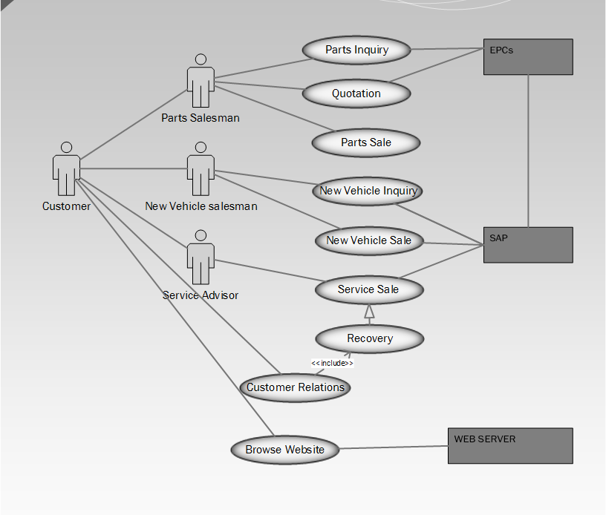
Fig3.1 Activity Diagram
KEY
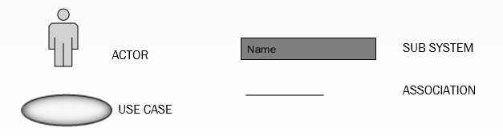

3.5 Data Analysis

3.5.1 Context Diagram of current System
Data analysis is a process of modelling data using analytical and logical reasoning thus with the goal of showing how the information is going to be useful. Data from different sources is collected, reviewed and then the data is analysed using context diagram and DFD.
Kendal (2002) defines context diagram as a way of outlining the boundaries of the existing system. From the collected data, a clear understanding of the current system was obtained. The context diagram below illustrates how the system works.
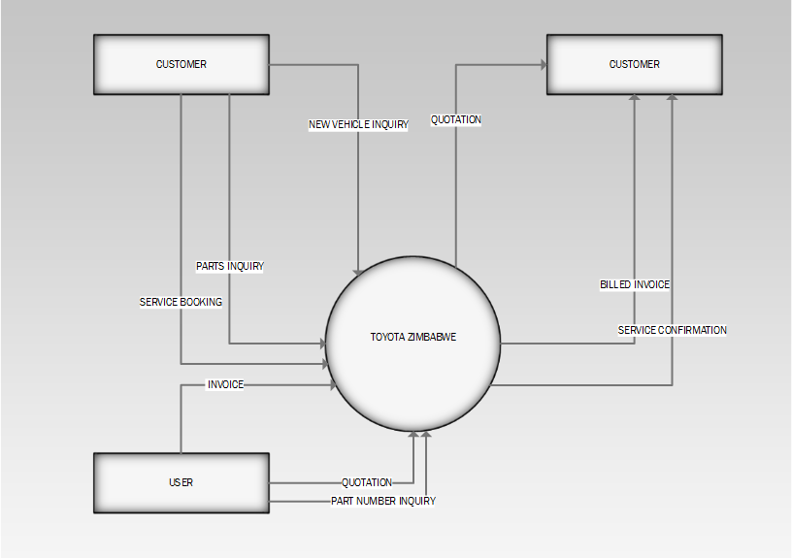
Fig 3.2 Context Diagram of the current system

3.5.2 Data flow diagram
From the analysis of the information collected from the interview and observation a logical data-flow diagram of the current system was developed, which illustrates system processes, information flows, and data requirements using easy-to-understand graphic symbols.
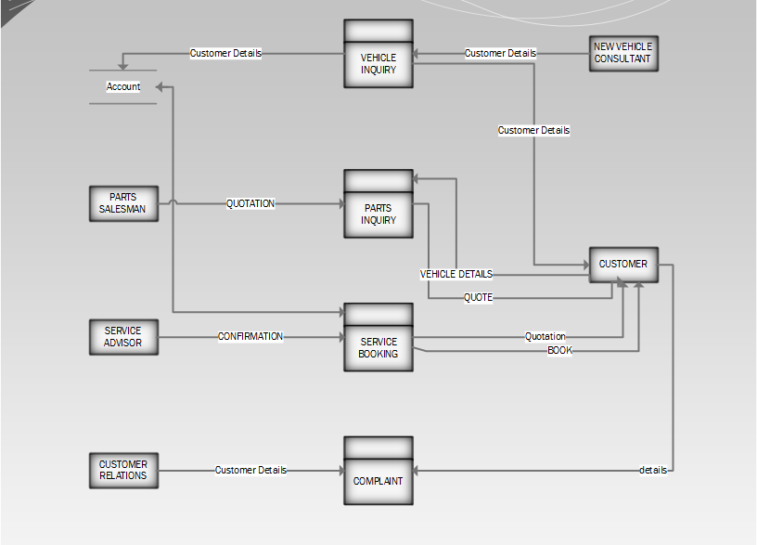
Fig 3.3 Data Flow Diagram of the current system
Key

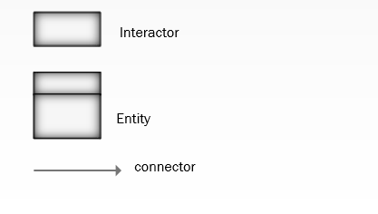

3.6 Weakness
After an in-depth review of “Toyota Zimbabwe App” Mobile application, problems were identified associated with the other mobile applications. There are limitations that need to be addressed and overcome. Such limitations are: usability, application speed, etc.
All of the applications have speed issues in downloading of forms and pictures, this can only be effective only if the user has fast internet, and this is usually a limitation especially on Zimbabwe’s mobile network service providers who offers a standard speed of maybe 1MB per second. Unless is one has other internet services like ADSL, VSAT or Fibre Optic connection.
This means the users should have fast internet service always. This implies that for a person the application requires smart phones that run on Android, Apple and Windows otherwise, it one has a Java phone it will not be possible.

3.7 Evaluation of Alternatives
The proposed application is a mobile booking, enquiry and informative application that aims to solve the problems of bookings and enquiry and general information that traditionally required a client to physically visit shop or call in.

3.7.1 Buying software packages
The developers considered whether it was worthwhile to buy an already developed system. This application would be universal. It would involve the purchasing of necessary hardware for compatibility with the software being purchased. This needs a lot of technical expertise for installation and maintenance of the software. Our analysis in this option enabled the developers to come up with the following advantages and disadvantages.
Advantages
- Requires less time to implement as the package is already designed and available
- Lower costs since the software resides in the multitenant environment where the hardware and the software license costs are low.
- Easy to use and perform proof of concepts since they already come with best practices and samples inside it.
- Acquisition costs are lower since costs are spread through all customers to the vendor.
Disadvantages

- Might not be able to address critical user needs because software packages depend on vendor for future upgrades
- Software packages are just umbrella solutions thus they are not designed or developed to meet specific problems
- They will be need for constant reference to the developer for training and maintenance of the system hence additional costs for training are incurred
- Buying off-shelve packages does not encourage end user participation and it requires extensive training

3.7.2 Outsourcing
This is a process of subcontracting the development process to IT experts outside the organization. In actual fact the application is developed with close involvement of the users who shall be using the app. After completion of development process, the software developer does system implementation; user share trained on how to use the application. This task is complete when all user requirements initially specified and those refined before its completion.
Advantages of Outsourcing
- Development of new and innovative ideas
- The organization can focus on its core business and can create a competitive advantage by reducing operational costs.
- In outsourcing, you can outsource an entire function or only a part of it.

Disadvantages of Outsourcing
- Outsourcing can expose the organization to quality risk and legal exposure.
- There are increased costs on training the users since there will be more reference to the developer.
- Outsourcing will obviously reduce staffing levels.

3.7.3 In-house development
This is the process whereby the organization uses their own labour and resources to come up with the proposed application system. This means that the organization or the company has programmers on its staff and develops the software internally and in-house development can provide revenue for continued development.
Advantages of In-house development
- User satisfaction- there is guaranteed user satisfaction since the developers understands user’s needs.
- Competitive advantage – advantages is gained through differentiating organizational systems from other competitors.
- Easy system support- it is easy for the organizational IT department to support its own application system since they are the ones who developed it.
- Cheap in the long-run- maintaining the application will not be costly since the developers are internal.
- Resources development- It allows the development of internal resources hand capabilities.

Disadvantages of In-house development
- Time-consuming since there is need to focus on the objectives of the system
- It requires more IT personnel
- There is problem with usability of the system.

3.7.4 Improvement
The current operation is a manually done so it will be difficult to improve it. The problems of the existing operation can be effectively solved by computerizing the operation like developing the application.
Advantages of Improvement
- With improvement the research information will always be in line with the application
- Time and costs for development is reduced

Disadvantages of improvement
- Data lose during migration.
- If the current system is prone to errors, then it means the organization will continue to have those errors.

3.7.5 Recommendations

A thorough risk analysis and cost benefit analysis was carried out and it showed that in-house development is the most ideal since it will enable users participation in the development so that errors will be reduced when the system is implemented even though it requires technical expertise. Hence a conclusion that the development of the proposed application system to be was made.

3.8 REQUIREMENTS ANALYSIS

A definite prerequisites dissection report was prepared not long after the data gathering techniques was finished. Requirements analysis is the complete assessment of an organization and its business, keeping in mind the end goal to distinguish system needs French (1992). The methodology of deciding clients' desires for the new or altered product. These characteristics, called prerequisites must be quantifiable, applicable and detailed.

3.8.1 Requirements Analysis
The proposed application system should be able to function in the following way:

Functional requirements
• Concurrent access to the application system: The users suggested that there is need for have a multi user system that can support many concurrent users . In other words, it means that the application should allow any number of users to uses the system/application with out directly affecting the other users information.
• Centralized database: It holds details of user’s logs and service problems.

Non-functional requirements
• User friendly interface: The application should allow simple and easy means of signing up , signig in and have interactive interfaces. The application must be easy to use to keep the user interested and improve user usage of the application .
• Reliability: The application should be reliable interms of efficiency and being responsiv that is it should do what it says it does and provide feedback to the user as soon as possible.
• Privacy: The application should make provisions to protect and keep the users data private and separated from other users who may use the same application . Users data can not be used else where without the users acknowledgement .
• Back-up: Ideally the database system should be backed-up continuously. The system administrator should maintain the application system and its databases to ensure the integrity and availability.

3.7 Conclusion.
After having gathered all the required information through questionnaires, interviews, observation and a brief analysis of the existing system the developer had to come up with an a way of enhancing the existing operations. The methods of research used were Internet survey, document analysis and informal bench marking (study of existing applications). The chapter explained the problems with each application and provided solutions on how to overcome the problems by proposing a new application to be developed. The next phase will be the design phases were all the gathered information would be applied.
CHAPTER FOUR: DESIGN PHASE

4.1 Introduction

In this phase, the analytical model was converted into a design model. After analyzing the current system and having successfully gone through the existing system, the developer had to come up with the idea of developing an application system. The activities that were carried out are; application system and database designs, which consists of class diagram and ERD.
This chapter outlines how the new application will work and this will be the design stage of the system. This phase will also deal with the Architectural design, Physical design and the Database design. Also this stage should give a complete overview of the overall structure of the application system and the level of modularization that will be desired. The system is to be designed along the following keywords and guidelines:

4.2 System design
During system design I defined the achitecture,components , modules, interfaces and data to satisfy the specified requirements above. Application of theory to software product development was used to come up with the design bellow. The system is designed using the top down aproach and takes into account all the variables that are needed.

Parsons (2012) defines system design as a process of defining the architecture, components, modules, interface and data for a system in order for the requirements to be specified. In order to design a quality application system that is far much better than the existing one the new system should possess the following features.

- Effectiveness
- Reliability
- Maintainability

Effectiveness
An application system that is well designed and of high quality should be easy to work with that is easy to understand interfaces and result in some benefit or reduction of costs. Any user who is going to use the application system should be involved in designing the application system so that they can operate it in the most efficient and effective way. The users should be able to find their way round the application system comfortably.
Reliability
A system that is well designed should be reliable and efficient whenever it is being. The system should be able to rule out the errors that were being faced by the existing system

Maintainability
The new application system should be designed in a way that it will be easy to maintain, thus in case where there are upgrades that need to be done and other developments that need to be made the available programmers in hand should be able to maintain the application system. The application system must be flexible when it comes to adapting to changes that is making it easy for modifications and technological updating.

4.2.1 Context Diagram of the Proposed System
Kendal, K.E (2002), defines context diagram as a way of outlining the boundaries of the existing application system. From the collected data, a clear understanding of the current operation was obtained. The context diagrams below illustrate how the system works.
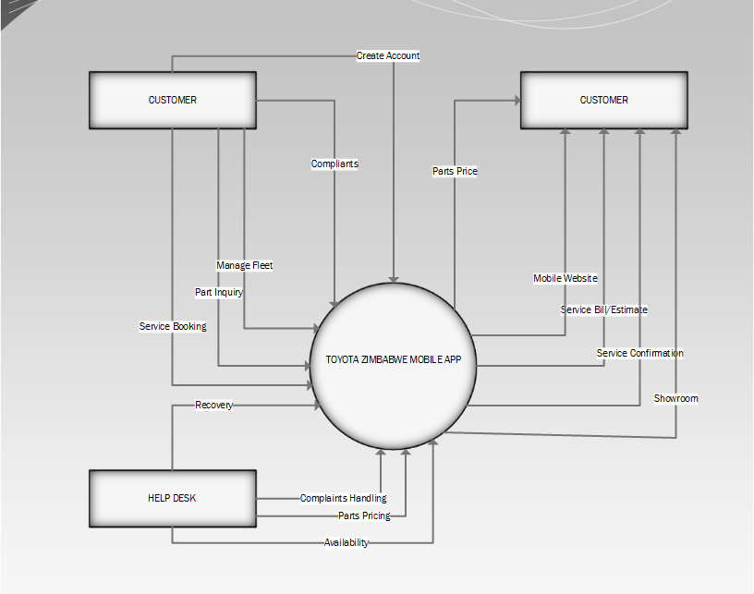

Fig 4.1 Context Diagram of the Proposed System
KEY

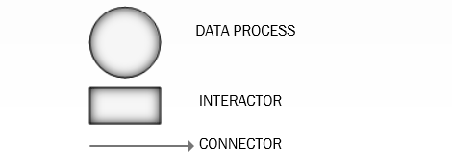
4.2.2 UML Use case for proposed system
A use case diagram at its simplest is a representation of a user's interaction with the system that shows the relationship between the user and the different use cases in which the user is involved. A use case diagram can identify the different types of users of a system.

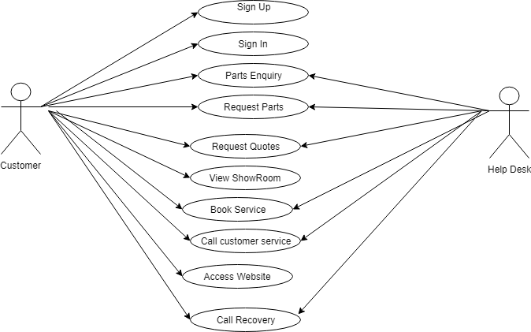
Fig 4.2 Use Case diagram for proposed application

4.2.2 Data Flow Diagram of the Proposed System
Murren et al (2008), Defines data flow diagram as a graphical representation of data flowing in processes or information systems. Data flow diagram entails business processes and activities in a clearhway by showing how dataflow within the system from one process to another.
P1
-Name -Surname –Cell Number -Email -City/Town
Customer details
D1
User

P2
-Vehicle Model -Engine Number –Vehicle Chassis - Number Plate -

Vehicle Details
D2

P3
-Update Content
IT Personnel

P4
-Update Client Enquiries
-Follow up
CR Personnel
Client Vehicle Details
D3

Fig 4.2 Data Flow Diagram the for the Proposed System
KEY

Entity Process Dataflow Data Store

4.3 Architectural design
The mobile application is structured as a multi-layered application consisting of user experience, business, and data layers as shown in the diagram below .The applications is a almost web-client type of where the business and data services layers are located on the device itself. Some of the users data and activities are also saved on an external data server, this cements the system architecture as highlited in the Requirement analysis section of the document .The system below shows the android application architecture :
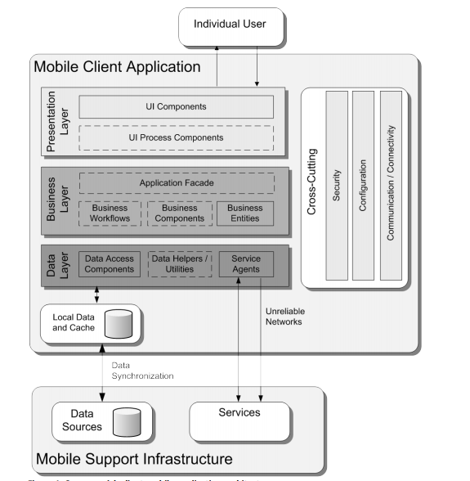
The above application design is designed with a concept of mudules in mind .The above architeture has the application divided into three layers that is the Presentation , Business and Data Layer. These layers seek to function separatly whilst complimementing the functionality of the application as a whole.
Presentation Layer: This layer handle all the user interface components that the users sees or interacts with .In this layers as well all the data coming from any other compent is helped to reley or render all the information to the specific UI (User Interface) component . In this layer in design pattens of desingn apps has alot of advantages as it helps to reduce process on the main Android Thread this will enhance the users experince of the application.
Business Layer:This layer this is where all the data to be rendered on the main screen is modeled that is all the objects are created in this layer basesd on a model day for example in the application there is the User model or class this class with its attributes help to model our data as data is precessed , for example data coming from the local database Realm to an external Database MySql . Also this Layer helps us receive data from external servers in the form of JSON(JavaScript Object Notation) . All the Business logic or model Logic is handled in this layer keeping the system in modules from .The data from this layer is also used in the Data layer directly as the rendering occurres on the main screen .
Data Layer: This layer is like the engine that puts everything together it requests data and pushes the required data to the necessary componets . In this layer there are classes that handle the requests and also uses utility class of the Android Framework and external libraries like Realm , GSON to get the data where it needs to go . Examples of Android Frame classes or utilities include Support V7 and V4 ,Threads , AsynTask ,Runnables , Json Parsers , Sqlite ,IO and many more . All the mechanisms to push the data to a local and external server via the Http protocol is done with the above componets just to cohesivley satisfy the system functions as a whole .

Powers, M and Martin, J. (1983) defines an architectural design as a high-level design and the point where the process of selecting modules starts, at the same time comprehending the interfaces and functionality of the architectural design. Thus the arrangement of data in a database schema is referred to as architectural design and it consist of three layers whish are physical, conceptual and application.
Architectural design is the plan for the hardware, software and communication infrastructure for the new application system, security and global support. The application system will operate using the internet connecting clients the “Toyota Zimbabwe App” application database. The architectural design of the application system will be comprised of the following:
- Mobile Phone/Device – This is where Android application reside.
- Web Service –Interface and backend where database will reside where both android application and customers will make http requests to .
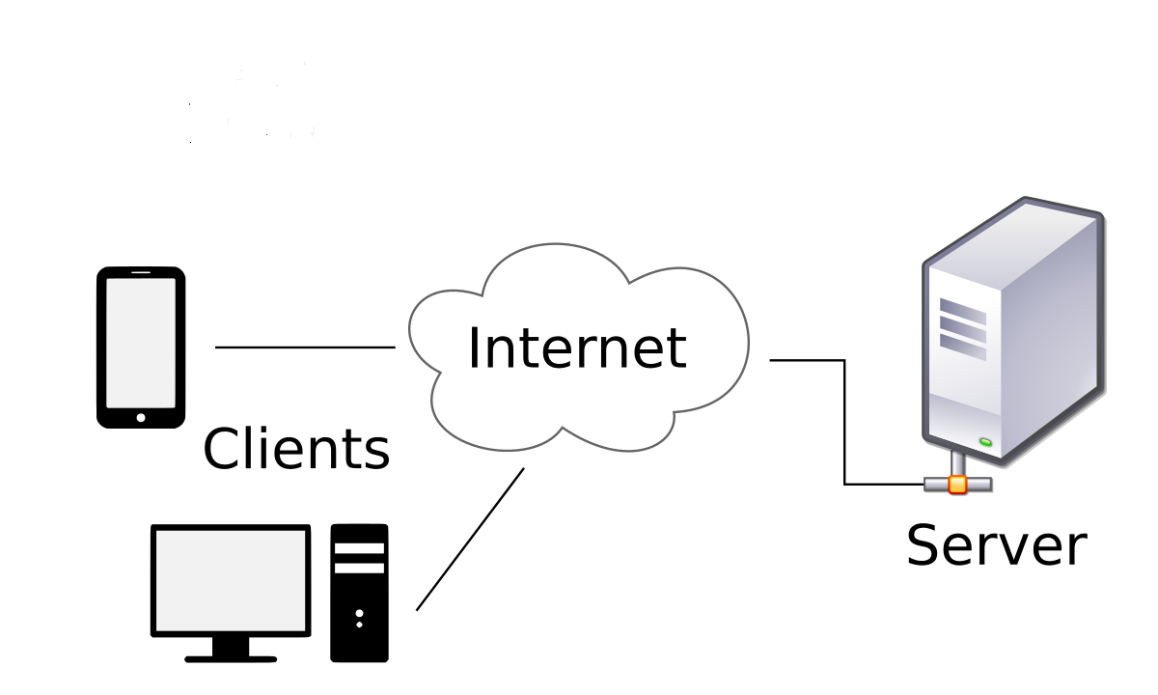

Fig. 4.3 Architectural Design

4.3.1 Physical design
Relates to the actual input and output processes of the system that is laid down in terms of how data is input in the system, how it is verified, processed and displayed to the user. The following requirements were investigated during physical design.
- Input requirements
- Output requirements
- Processing requirements
- System control and recovery
These physical design requirements were broken down into three sub tasks which are user interface design, data design and process design. In interface design we were concerned with how users input information into the system and how the system presents data to the user. In data design we were concerned with how the data is presented in the system. Process design is concerned with how data moves through the system and how and where it is validated and transformed as it flows into, through and out of the system.

4.4 User Interface design
The user interface is one of the most essential parts of any application because it determines how easily to make the application work as wanted. A powerful application with a poorly designed user interface has little value. Graphical user interfaces (GUIs) that, icons, and pop-up menus have become standard on mobile phones and even personal computers. In the design of the mobile application user interfaces, major design factors were considered, these include:
- Interface Visibility: One of the most significant elements of a good user interface is of the application’s status. Users should notice immediately the effect of their requests/actions and see whether their actions have actually led to the expected results. Error messages were appropriate designed in the case of wrong input.
- Consistent Interface: Consistency in interface design makes it easier for the users to use the application functionalities without having to remember the different steps to perform the functions. Hence, the interface design of the electronic diary mobile application is similar and consistent throughout.
- Minimal Number of Colours Used: A good interface also considers the use of colors with not more than four colors on the screen, except for the graphics. Dark and light blue colors were used for the mobile application.
- Navigation Design: The mobile application uses the hierarchical navigational structure. All the functions and contents of the application can be accessed from any point.

4.4.1 Main menu design

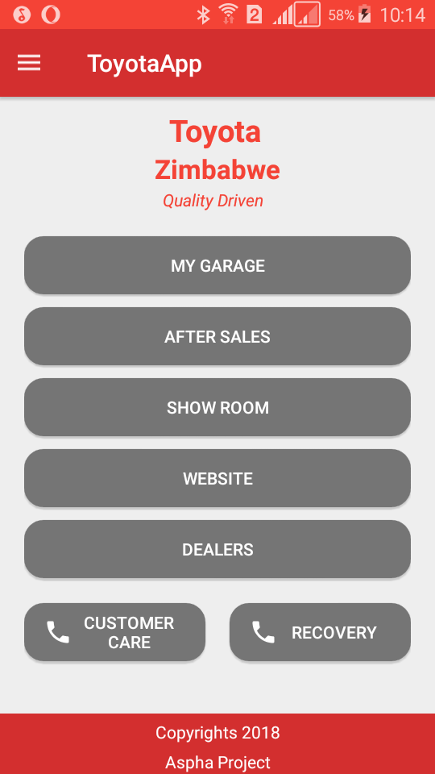
Fig 4.4 Main Menu Design

4.4.2 Input design
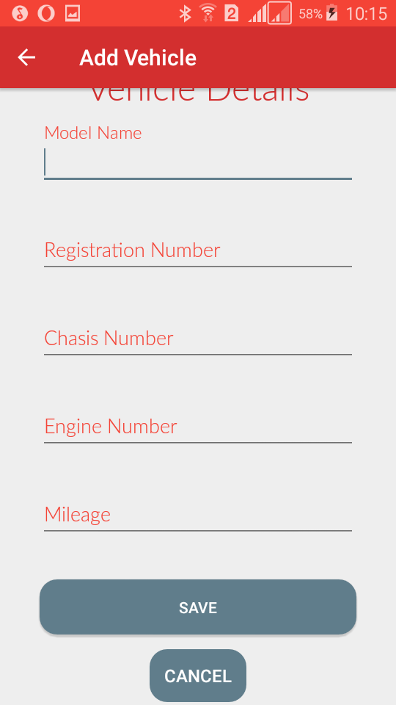
Fig 4.5 Form Page

4.4.2 Output design
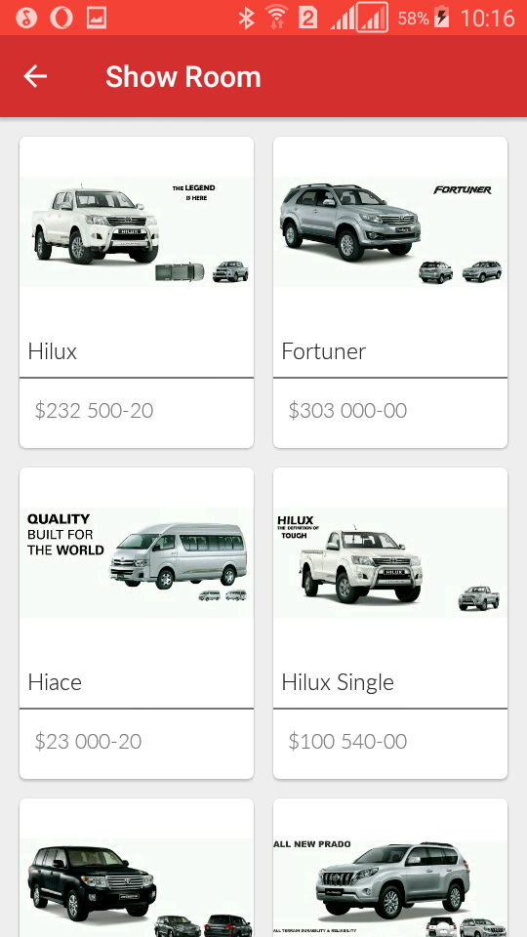
Fig 4. 6 Showroom Menu by category

4.5 Process Design
Program Pseudo Code
Below in this section I will show the pseusdo code of the major functionalies especially for dtabase oprations and http server connections.As this demonstration goes I may even show the system functions over haul .

Adding a new User’s details,
Validate user’s input
IF Input is not valid
Notify user
ELSE
Connect to database
// check for duplication
IF user exists

Check for connection to database

Check for required fields
If correct then
Check to make sure details or records do not already exist
If exists abandon update else save the new details or records
Else
Rollback and give user opportunity to correct
Updating a Details or Records
Check for connection to database
If not connected then connect, otherwise
Let user input the search criteria for required details or records
Check criteria is valid
If valid search for details or records
If found, then
Retrieve and display details or records in update mode
Ensure that only updatable fields are updated
After update check if data is correct
If correct then update/save new details or records
Else
Rollback and give user chance to correct
Else
Display message “Record not Found”
4.5 Program Design
The system is to be designed using Android Java or Android JVM (ART) and MySQL for database design. Program design involves the design of the modules and classes in the application that is under construction.

4.6 Security Design
Security is a means of restricting unauthorized users from accessing the mobile application system. It also calls for the authorized users to access the mobile application system according to their set privileges granted to them by the database administrator. Security can also be implemented using physical means like locking computer rooms and server rooms, while usernames and passwords are used to implement security software wise.

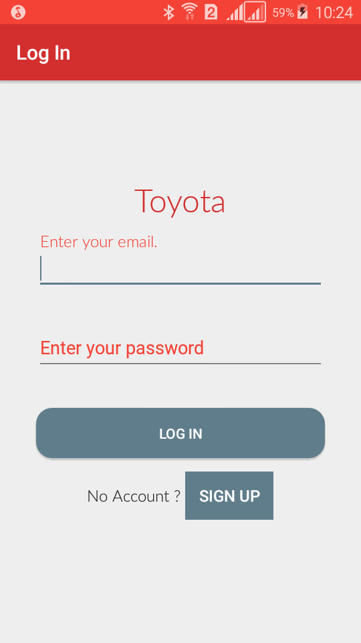
Fig 4.8 Login screen

4.7 Database Design
Mysql
In data design we were concerned with how the data is presented in the system. We managed to define the data characteristics and processes and to specify the data types that are required. We used UML ERD conceptual frameworks as shown in the database below and the database script is given

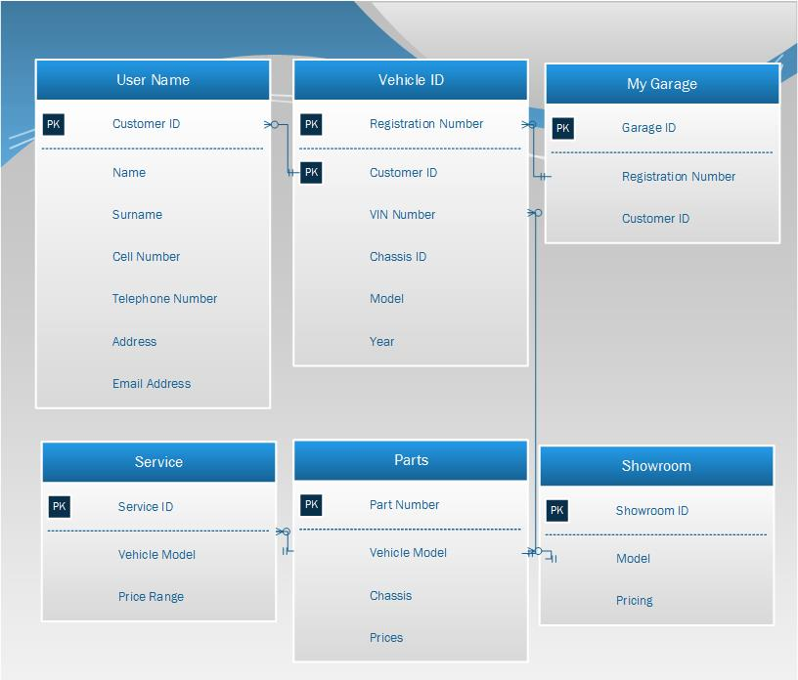
Fig 4.7 Database design

4.3.2 Database Tables

Following is the database scripts for the database we have designed.
CREATE TABLE Customer (Id int IDENTITY NOT NULL, CustomerID varchar(15) NOT NULL UNIQUE, Name varchar(50) NOT NULL, Surname varchar(50), Address varchar(50), PhoneNumber int, TelephoneNumber int, ), Email Address varchar (50)NOT NULL UNIQUE, PRIMARY KEY (Id));
CREATE TABLE VehicleID (Registration Number varchar(15), VinNumber varchar(25), ChassisID varchar(25), [Year] datetime, Rating varchar(15), Model varchar(15) NOT NULL);
CREATE TABLE [Parts] ([PartNumber] varchar(15) NOT NULL, PRIMARY KEY ([Price]));
CREATE TABLE [Showroom] (Id int IDENTITY NOT NULL, Model varchar(50), Colour varchar(50), PRIMARY KEY (Id));
CREATE TABLE Service (Id int IDENTITY NOT NULL, Model varchar(25), Price varchar(50), PRIMARY KEY (Id));
Realm Database Design

4.9 Backup Design
The backup of data from the application system should be done on a daily basis, by copying the whole database to an offsite server, and in this case an offsite storage is used as a replica to the main database server in. If the main server crashes, information can still be recovered from the offsite server.
Some onsite backup can also be used by using Hard disk drives and compact disks to copy the data to external storage devices. Disk mirroring can also be used, which is a process of partitioning the hard disk so that it will contain the same information in both partitions as a backup measure in cases of disasters. If one mirror partition crashes, information can be recovered safely from the other mirror partition.
Uninterruptible Power Supply is also used at the central database and at all regional sites so that data is not lost in cases of power cuts. The UPS also allows the system to be properly shutdown in cases of power losses.

4.10 Test design
During test design I used equivalence classes and boundary value analysis to design the test cases of the system. Equivalence classes were formed from the temperature range and different stages of curing and also from the different time requirements of the system. Boundary value analysis was there to analyse the system behaviour on the boundary values of each range during execution of the system. Below are the given sample test cases of the system and the results on the outputs.
The above test cases were executed during test execution and the results were recorded for the purposes of analysis using test procedures that I designed during test planning. Regression testing to prove the code fixes that were done during test execution does not cause ripple effect after execution of the code. All the test results were logged so as to also compare the actual results and the expected results of the system. This also was also done to prove for reporting purposes. Evaluation and the exit criteria was based on the risk assessment of the project. During test planning I have set a point where at that point testing is enough and that point is when seventy-five percent of the statement coverage is achieved.

4.2 Conclusion

As seen this chapter concludes the actual logical and physical designing of the proposed invoicing system. Once Approved by Management the above will be used as the baseline for the Development Stage of the project. The User interface Screens indicated on this document
- .
Finally there will be a reports section which will list all the reports that the system will generate. These reports will be designed after test data has been inputted and verified. This therefore concludes this Chapter.

REFERENCES

1. Wolber David, Hal Abelson, Ellen Spertus, and Liz Looney, “App Inventor: Create Your Own Android Apps”, O'Reilly Media, Inc., 2011.
2. Morelli Ralph, Trishan de Lanerolle, Pauline Lake, Nina Limardo, Elizabeth Tamotsu, and Chinma Uche, "Can Android App Inventor Bring”
3. Sharon Panth and Mahesh Jivani, “Designing Home Automation system (HAS) using Java ME for Mobile Phone”, International Journal of
4. Electronics and Computer Science Engineering (IJECSE), Vol. 2. No. 2, pp. 798-807, 2013.
5. Sharon Panth and Mahesh Jivani, “Home Automation System (HAS) using Android for Mobile Phone”, International Journal of Electronics and Computer Science Engineering (IJECSE), Vol. 3. No. 1, pp. 1-11, 2013
6. Jawarkar, N. P., Ahmed, V., Ladhake, S. A. & Thakare, R. D., Micro-controller based Remote Monitoring using Mobile through Spoken Commands. Journal of Networks, 3(2), 58-63, 2008
7. Malik, S. H. K., Aihab, K. and Erum, S., SMS Based Wireless Home Appliance Control System (HACS) for Automating Appliances and Security. Issues in Informing Science and Information Technology, 6, 887-894, 2009.
8. Ahmad, B. I., Yakubu, F., Bagiwa, M. A and Abdullahi, U. I., Remote Home Management: An alternative for working at home while away.
World of Computer Science and Information Technology Journal (WCSIT), 1, 4, 144-147, 2011

APPENDIX A

This section contains the associated documents that were deliverables in the course of the project contains the interview questions and the simulation process outputs and the associated document used in the project.

Interviews

Focus of the interviews is seeking clarification on unclear areas and acquires the stakeholder’s opinions on the strengths and weaknesses of the current manual system of distributing music physically. In order to avoid bias and prejudice to the response, context free questions were employed. The feasibility of the project was also derived from the interviews that we carried out and it also helped me to understand the user characteristics and also the environment in which the software will be operating during its life.

Sample interview questions
The following questions were asked to understand the existing system before we design the new system that is to be built. The interview was done one on one with the users and the sample size was four for the users of the system. The criteria used were to interview a music producer and two musicians to evaluate their experience.

Musicians:
Q. What is the main challenge you are facing with other music applications?
_______________________________________________________________________________________________________________________________________________________________________________________________________________
Q. What is your target as musicians in terms of audience after a song is released?
_______________________________________________________________________________________________________________________________________________________________________________________________________________
Q. How are you selling your music abroad?
_______________________________________________________________________________________________________________________________________________________________________________________________________________
Q. What is affecting your growth as musicians?
_______________________________________________________________________________________________________________________________________________________________________________________________________________
Q. What application functionality do you expect from programmers or developers?
_______________________________________________________________________________________________________________________________________________________________________________________________________________
Q. Are you willing to endorse a new music application that caters for your requirements?
______________________________________________________________________________________________________________________________________________________________________________________

Music producer:
Questions that were used to interview the Music producer and the owner of the studio for operational and technical feasibility. The feasibility of the project was assessed from these type of questions.
Q. Do you have a phone?
_______________________________________________________________________________________________________________________________________________________________________________________________________________
Q. Type of phone you have?
_______________________________________________________________________________________________________________________________________________________________________________________________________________
Q. Use of any production application system before?
_______________________________________________________________________________________________________________________________________________________________________________________________________________
Q. What do you need exchange music files for post-production without affecting quality?
_______________________________________________________________________________________________________________________________________________________________________________________________________________

Q. Any cost involved during post-production?
_______________________________________________________________________________________________________________________________________________________________________________________________________________
Q. Speed of internet connectivity available at the organisation?
_______________________________________________________________________________________________________________________________________________________________________________________________________________
Q. How do you do to access the files from other producers?
_______________________________________________________________________________________________________________________________________________________________________________________________________________

Q. What affect quality of post produced music from other producers abroad?
_______________________________________________________________________________________________________________________________________________________________________________________________________________
Q. Labour required during the music distribution process?
_______________________________________________________________________________________________________________________________________________________________________________________________________________
Q. What do you think about the new system?
_______________________________________________________________________________________________________________________________________________________________________________________________________________
Q. Problems of the existing system?
_______________________________________________________________________________________________________________________________________________________________________________________________________________
Q. How does the current system secure your produce?
_______________________________________________________________________________________________________________________________________________________________________________________________________________

Q. If a new system is to be developed to counter the problems you are currently facing are there any areas you think require special attention.
_______________________________________________________________________________________________________________________________________________________________________________________________________________

APPENDIX: B OBSERVATION SHEET

Observation guide schedule.
Date: ……………………………………………
Time: ……………………………………………
Observation…………………………………………………………………………………………………………………………………………………………………………………………………………………………………………………………………………………………………………………………………………………………………………………………………………………………………………………………………………………………………………………………………………………………………………………………………………………….
Conclusion…………………………………………………………………………………………………………………………………………………………………………………………………………………………………………………………………………………………………………………………………………………………………………………………………………………………………………………………………………………………………………………………………………………
During observation, I discovered that the production process involves stages of some postproduction where some files go for mastering to other producers. This involves vocal compression delaying, equalisation, and other mastering essentials like izotoping effect. The quality of the output of the sound depends on the way the data files were rendered and sent, some formats are not good for unprocessed data files like mp3 format should not be used. Most of the upcoming producers and artists do not have proper equipment to support their abilities and passion for music production. Most of the application users possess mobile phones and can use them during the production process on the go for convenience sake, especially for music distribution and marketing. If sound is not closely monitored, the quality of the output is poor and if the output should be well marketed to attract revenue to enable music industry grows.
Conclusion

The cost of travelling and distribution and exchange of music files can be reduced due to the development of the new application that caters for all the music service at once at a cheaper and convenient way, thus improving local music reach thus making it competitive on the international thereby, environment in terms of manufacture of compact disc and their sleeves that may pollute, and the labour required during the distribution and marketing process. An application system can be designed that can reduce the paper and plastic and also that secures music from piracy and also that creates revenue to underground artists

Further Research

The system can be designed to meet other requirements such as anti-piracy of music files and also for fair music ratings that can be used for awards and other music events. It can also be used in monitoring the genre that most listeners want compare to others, so that musicians can do music that the listeners want most.

